**4.**     **PROGRAM DESIGN**

*[Describe how program design is done.  What are the programs making up each system/software module?]*

**Main Functions**

**Room availability and booking management**

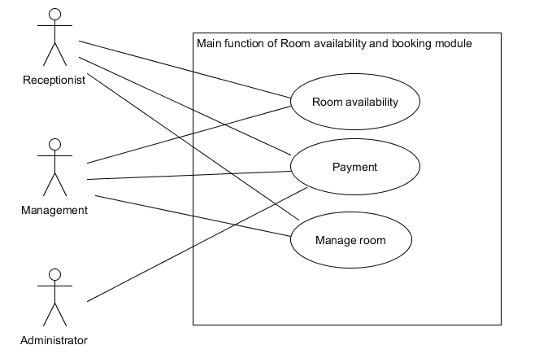

The room availability and booking management diagram revolves around these 3 main actors, Receptionist, Management and Administrator

Receptionist and Management involves payment, room availability and managing the room such as different request in certain room.

Administrator only involve the payment method due to them being in charge of this main function

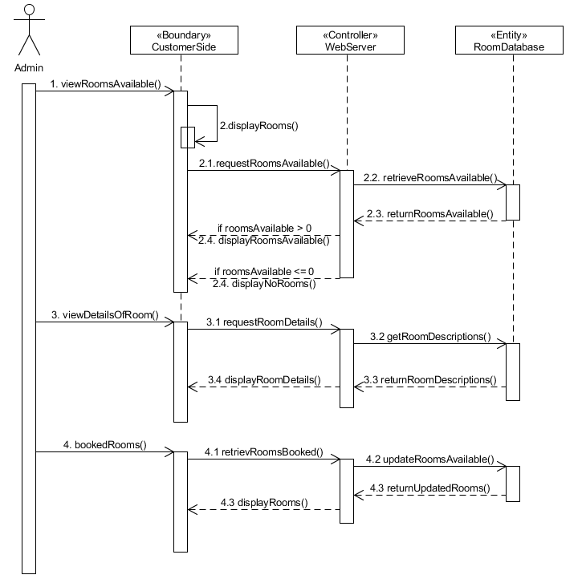

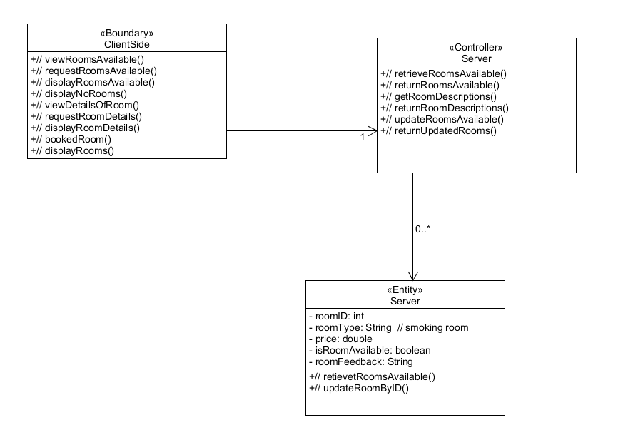

**Housekeeping and staff management**

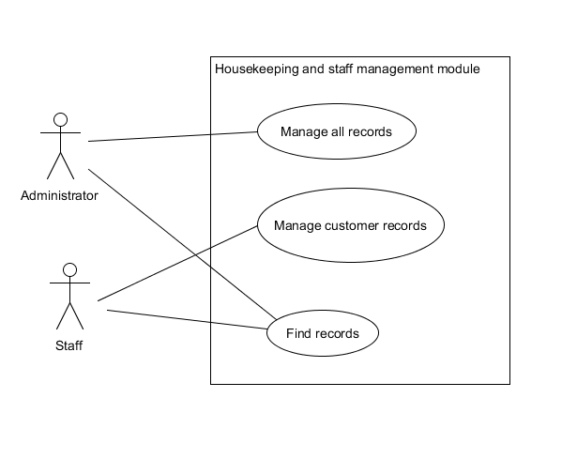

Mr Wang, being the administrator will get full control of the records and functionality of CRUD (Create, retrieve, update, delete)  while his staff will not get full records but only customer CRUD and search functionality

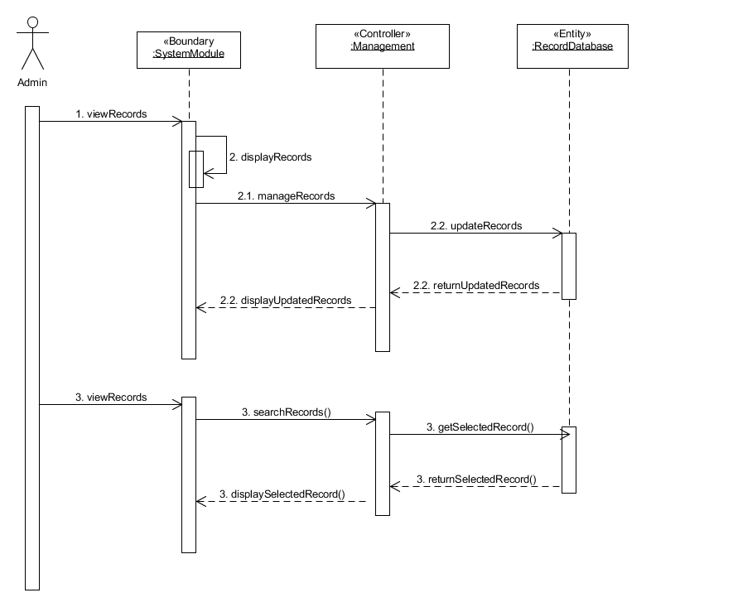

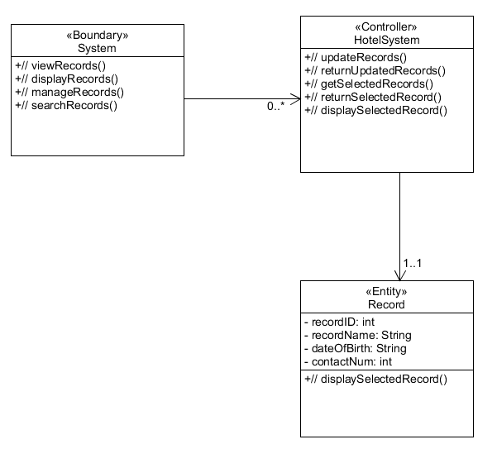

**Report module**

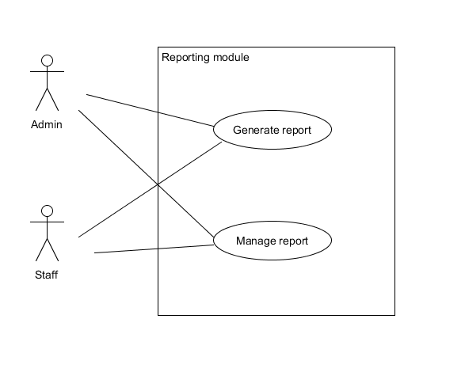

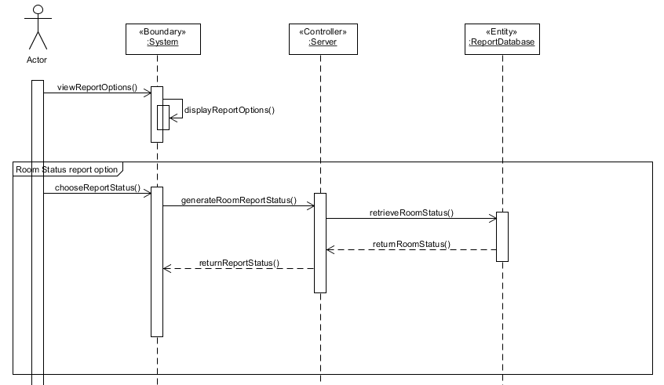

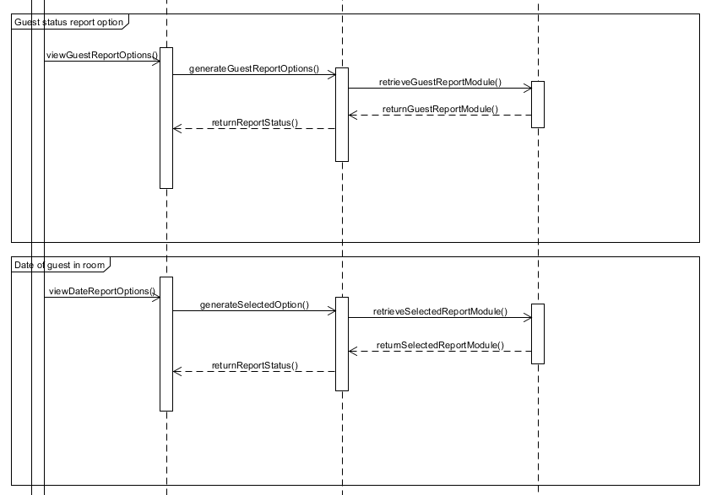

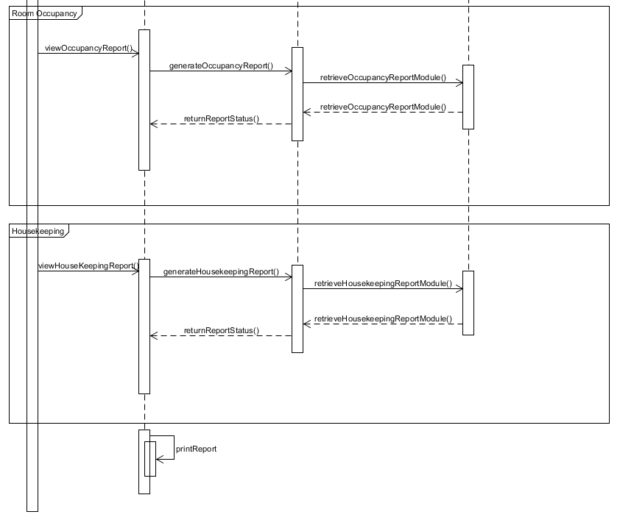

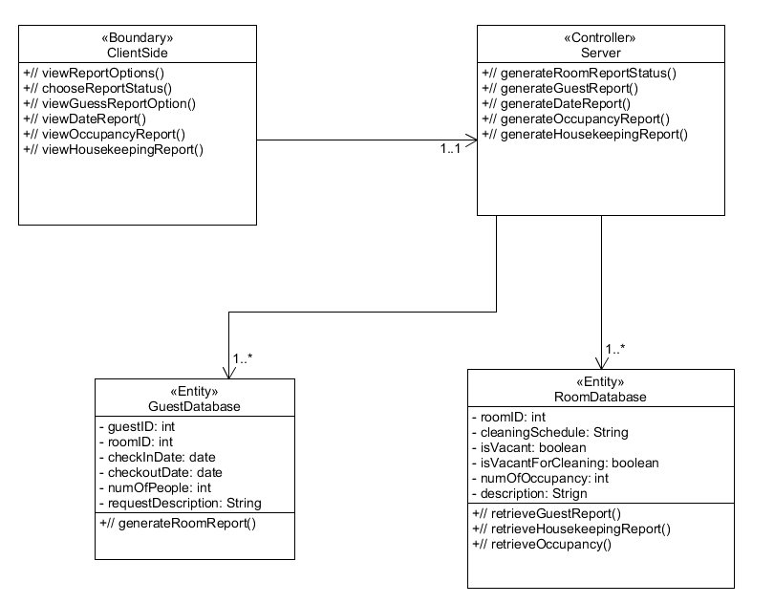

The program design of the reporting module shows on how the users can get the report which they want and checking the room details on what the client wanted based on Mr Wang interview on the reporting modules.